Pastor’s Corner:
Welcome Fr. Alex Urena

Father Alejandro (Alex) Urena was Incardinated into the American National Catholic Church (ANCC) by Bishop George Lucey on January 20, 2024, and is now an Associate Pastor at Holy Family Catholic Church.

Fr. Alex was born in a small town in the state of Jalisco, Mexico called Totatiche. At the age of twelve he left his family and entered minor seminary to begin his studies. He completed six years of minor seminary in the Archdiocese of Guadalajara, Jalisco. He then came to the United States working in construction and also at the Hotel Encanto in Las Cruces, New Mexico. In 2005 he joined the Diocese of Las Cruces and began college in Missouri at Conception Abbey where he earned his BA in Philosophy. After five years of college, he went to St. Mary’s seminary in Houston to complete his M. Div. in theological studies. He was ordained to the priesthood on May 30, 2015, by Roman Catholic Bishop Oscar Cantu. Father Alex’s first assignment was as pastor at St. Albert the Great, Newman Parish in Las Cruces. Following his ordination, Fr. Alex continued his education and received a Master of Clinical Mental Health degree. He now works locally in the mental health field.

We are excited about the gifts and energy Fr. Alex brings to our parish and welcome him as a member of our ministry. Please welcome him.

Fr. Jim
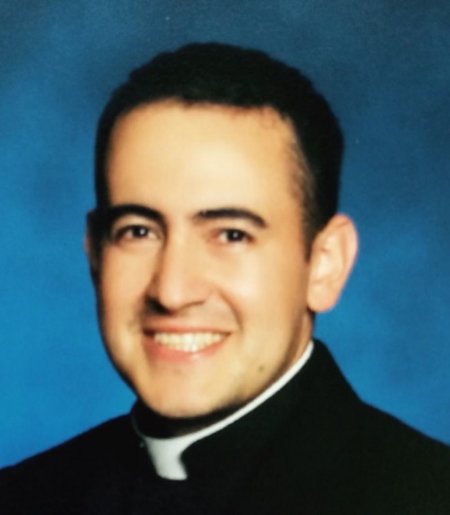
Treasurers Report:
Collection for the week ending 1/21: $668.00
Thank you for your generosity.
To the right is the QR code for Holy Family Community (Holy
Family ANCC). This can be utilized to donate to the church if
You wish.

2023 FIT Report:
If you need verification of 2023 donations for filing your taxes, contact Br. Charlie.
Religious Education Classes:
Religious Ed. Classes for Baptism and Confirmation will resume Sunday, February 4, 2024. Please contact the parish office for additional information or to register.

Valentine’s Potluck Dinner:
Mark your calendars to attend our potluck dinner celebration for Valentine’s Day on Saturday, February 17 after the 4:30 Mass in the parish hall. Sign-up sheets are posted in the parish hall.

Remember in Your Prayers*
*Prayers or Eucharist home visits can be requested in the white notebook located next to the hymnal bookcase.

Celeste A. (Fr. Louie) 12/25 God’s Blessings and Prayers
James H. (Br. Charlie) 12/25 Health Concerns
Sr. Helen (Fr. Jim) 12/25 Health Concerns
Maria E. (Fr. Jim) 1/3 Hospice Care
Rudy A. (Br. Charlie) 1/6 Health Concerns
Ken R. (Fr. Jim) 1/11/2024 Health Concerns
Roxanna N. (Fr. Jim) 12/25 May She Rest in Peace
Carmen (Martha M.) 1/14 Health Concerns
Alicia T. (Elizabeth H.) 1/14 Health Concerns
Ben & Serena W. (Elizabeth H.) 1/14 Health Concerns
Theresa S. (Elizabeth H.) 1/14 Health Concerns
Lionel S.(Loretta Y.) 1/17 God’s Blessings and Prayers
Eunice and Steve (Martha M.) 1/22 Health Concerns
Molly (Martha M.) 1/22 Hospice Care

Fourth Sunday in Ordinary Time
Celebrant: Fr. James Lehman, FCM
Reading: Kathie
Order of the Mass: Page #134 in the Hymnal.
Entrance: Sing to the Lords Goodness #532
Penitential Rite/Kyrie #136
Gloria #138
Readings:
- Deuteronomy 18:15-20.
Psalm: 91 #50 Be With Me. Be with me, Lord, when I am in trouble, be with me, Lord, I pray.
- 1 Corinthians 7:32-35.
Alleluia #266
- Mark 1:21-28.
Homily
Profession of Faith #142 or Apostles’ Creed #143
Preparation of the Altar: Here I Am, Lord #671
Service Music:
Santus (Spanish handout)
Memorial Acclamation (Spanish handout)
Amen (Spanish handout)
Our Father (spoken)
Agnus Dei #152
Communion Music: Pescador de Hombres #678
Concluding Rite: #154
Parish Announcements
Final Blessing
Recessional: Be Not Afraid #596

Readings for February 3 & 4, 2024; The Fifth Sunday in Ordinary Time.
Reader:
- Job 7:1-4, 6-7.
- 1 Corinthians 9:16-19, 22-23.
- Mark 1:29-39.

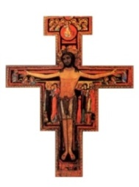
Holy Family American National
Catholic Church

A Catholic Church Where All Are Welcome
702 Parker Road
Las Cruces, NM 88005-2149
Phone: 575-644-5025 or 575-524-6807
WEBSITE: http://www.holyfamilyancc.com

Pastor-Fr. James Lehman, FCM
Email: jlehman@anccmail.org

Associate Pastor-Fr. Louie Amezaga
Email: lamezaga@anccmail.org

Associate Pastor-Fr. Rogelio Martinez
Email: rmartinez@anccmail.org

Associate Pastor-Fr. Alex Urena
Email: aurena@anccmail.org

Church Secretary- Bill Sampson
Church’s Email: holyfamilyancc@qwestoffice.net

Music Director---Eike Gunnarson
Email: eikegun@aol.com

Church Office Hours:
Tuesday – Friday: 1:00p.m. – 5:00p.m.
Saturday Eucharistic Liturgy: 4:30 p.m.
Sunday Eucharistic Liturgy: 10:30 am
St. Ignatius of Antioch (circa 107 AD) was the first to use the word Catholic (Greek word is catha holos) meaning the “gathering of the whole” of the people. The ancient undivided Church adhered to the early Ecumenical Councils. There are several Catholic Churches in this tradition. The Assyrian Church of the East, and Oriental Orthodox left in the 5th Century and the Roman Catholic and Eastern Orthodox separated in 1054. Others left later: Anglican (16th Century) and Old Catholic Churches (19th Century) but all are part of this Catholic tradition and believe there is a need for apostolic succession of bishops. We also share a common liturgical, sacramental, and theological tradition.

